RESOLUTION NO.__________

RE: CERTIFICATE OF APPROPRIATENESS UNDER THE
PROVISIONS OF THE ACT OF THE PENNSYLVANIA
LEGISLATURE 1961, JUNE 13, P.L. 282 (53
SECTION 8004) AND BETHLEHEM ORDINANCE NO.
3952 AS AMENDED.

The applicant proposes to replace the windows at 428-444 Main St. (Moravian Bookstore).

NOW, THEREFORE, BE IT RESOLVED by the Council of the City of Bethlehem that a Certificate of Appropriateness is hereby granted for the proposal.

Sponsored by: (s)

(s)

ADOPTED BY COUNCIL THIS DAY OF

(s)
President of Council

ATTEST:

(s)
City Clerk

HISTORICAL & ARCHITECTURAL REVIEW BOARD

The Applicant proposes to replace windows, at 428-444 Main St. (Moravian Bookstore).
APPLICATION #3-1

Moravian College
1200 Main St.
Bethlehem, PA 18018

OWNER:

__________________________________________________________________________

The Board upon motion by Phil Roeder and seconded by Marsha Fritz adopted the proposal that City Council issue a Certificate of Appropriateness for the following:

- The existing windows on the right side of the building (Currently three (3) panes.) shall also be removed and replaced with four (4) panes of glass to match the rhythm and frame profile of the new aluminum bi-folding windows to be installed on the left side of the building façade.
- The window frames will be painted blue to match the color of the building’s trim.
3. The motion was unanimously approved.

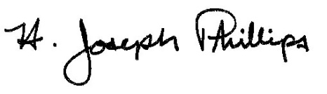 By:__H. Joseph Phillips___________

Title: __Historic Officer____________

Date of Meeting: February 6, 2019

