RESOLUTION NO.__________

RE: CERTIFICATE OF APPROPRIATENESS UNDER THE
PROVISIONS OF THE ACT OF THE PENNSYLVANIA
LEGISLATURE 1961, JUNE 13, P.L. 282 (53
SECTION 8004) AND BETHLEHEM ORDINANCE NO.
3952 AS AMENDED.

WHEREAS, it is proposed to secure a COA to install the company name in the window at 321 South New Street (Lara Bly designs).

NOW, THEREFORE, BE IT RESOLVED by the Council of the City of Bethlehem that a Certificate of Appropriateness is hereby granted for the proposal.

Sponsored by: (s)

(s)

ADOPTED BY COUNCIL THIS DAY OF

(s)
President of Council

ATTEST:

(s)
City Clerk

HISTORIC CONSERVATION COMMISSION

CASE #687 -- It is proposed to install the company name in the window at 321 South New Street (Lara Bly designs).

OWNER / APPLICANT: Newco Holdings / Lara Bly-Allaik

The Commission upon motion by Mr. Cornish and seconded by Ms. Starbuck adopted the proposal that City Council issue a Certificate of Appropriateness for the proposed work as presented (with modifications) described herein:

- The proposal to install the company name in the storefront window was presented by Lara Bly-Allaik.
- Approved signage includes:
  - company logo and slogan as vinyl lettering on inside surface of storefront window, with logo and slogan evenly spaced on either side of central aluminum frame
  - logo “Lara Bly” is in stylized cursive lettering with word “designs” in much smaller lower-case, sans-serif lettering at top right of logo; logo is 48” wide x 8.85” tall and positioning of logo is centered along overall 6-ft. height of storefront window
  - slogan “a fashion design studio & boutique” is 48” wide x 2.67” tall in sans-serif lettering and positioned at bottom of storefront window
  - color of all lettering revised from bright white to warm white to comply with approved color for period-appropriate signage within Historic Conservation District
- The motion for the proposed work was unanimously approved.

JBL: jbl
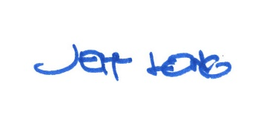

By:

Date of Meeting: March 18, 2019 Title: Historic Officer

