RESOLUTION NO.__________

RE: CERTIFICATE OF APPROPRIATENESS UNDER THE
PROVISIONS OF THE ACT OF THE PENNSYLVANIA
LEGISLATURE 1961, JUNE 13, P.L. 282 (53
SECTION 8004) AND BETHLEHEM ORDINANCE NO.
3952 AS AMENDED.

The applicant proposes to replace an existing hanging sign in the covered entrance alcove at 428-444 Main St. (Moravian Book Shop).

NOW, THEREFORE, BE IT RESOLVED by the Council of the City of Bethlehem that a Certificate of Appropriateness is hereby granted for the proposal.

Sponsored by: (s)

(s)

ADOPTED BY COUNCIL THIS DAY OF

(s)
President of Council

ATTEST:

(s)
City Clerk

HISTORICAL & ARCHITECTURAL REVIEW BOARD

The applicant proposes to replace an existing hanging sign in the covered entrance alcove at 428-444 Main St. (Moravian Book Shop)

APPLICATION #3:

Moravian College
1200 Main St.
Bethlehem, PA 18018

OWNER:

__________________________________________________________________________

The Board upon motion by Diana Hodgson and seconded by Marsha Fritz adopted the proposal that City Council issue a Certificate of Appropriateness for the following:

1. The sign will be a single sided hanging sign, 36” x 48” (1,728 square inches).

2. Background color will be Tricorn Black (SW 6258) with Serif lettering, painted
silver.

3. The pinstriping around the perimeter to be silver color to match the lettering.

4. To be attached to the existing metal dowel and wood hanging bracket.

5. The motion was unanimously approved.

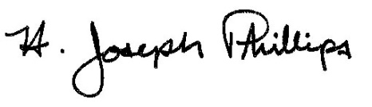 By:__H. Joseph Phillips___________

Title: _Historic Officer____________

Date of Meeting: April 3, 2019

